CS 305 Project One

Document Revision History

Version | Date | Author | Comments
1.0 | 1/24/26 | Sheyenne Hisey

Client



Developer
Sheyenne Hisey

- Interpreting Client Needs

Artemis Financial handles sensitive financial data related to clients such as savings, retirement, investment, and insurance plans. Secure communication is vital to the company to keep client information safe and secure from any potential attackers. A lack of secure communication could result in the loss of clients and therefore income, as well as legal consequences of this data being leaked. The company did not disclose whether they deal with international transactions, but due to it being based in finances there is a high likelihood that it does deal with international clientele. There are multiple government regulations that must be followed to keep client data secure, depending on where Artemis Financial is based is what laws they would need to follow. If Artemis Financial uses any form of client cards, they would need to follow PCI-DSS rules. External attacks on the company could include attacks such as DoS events or injections due to it being a web application, data breeches are also a main external concern, as well as the exploitation of any vulnerabilities the software may be having. Swapping to open-source libraries can assist in Artemis Financials’ modernization efforts by helping speed up the development process and evolving web application technologies can improve system functionality and security.

- Areas of Security

There are multiple areas of security to apply to Artemis Financials’ software application, the first one being Input Validation. Input Validation is important as this ensures that clients are inputting correct information into the available fields. This also helps to shield from injection type attacks. Due to the application using the RESTful API, it is important to ensure that the application is utilizing secure API interactions. Cryptography will be important in this web application as it will help secure client information. Code errors should be minimized as much as possible to not allow for any openings for attacks, this also goes along with code quality that should follow industry best practices.

3. Manual Review

Artemis Financial’s web application currently has little to no input validation, this is a vital piece when working with sensitive information and is a large vulnerability. The greeting and business name are not validated and have no constraints. There is no cryptography currently in place to hide valuable data. The account number and balance are currently open to see and are not hashed or encrypted. The code is incomplete, will give errors, and has no secure handling as of now. All values seem to be posted to the same document. Currently the client communicates with HTTP to the server, therefore the connection is not secure. The code currently has both the username and password for the database which could lead to huge security issues if someone got access to the internals of the application.

4. Static Testing

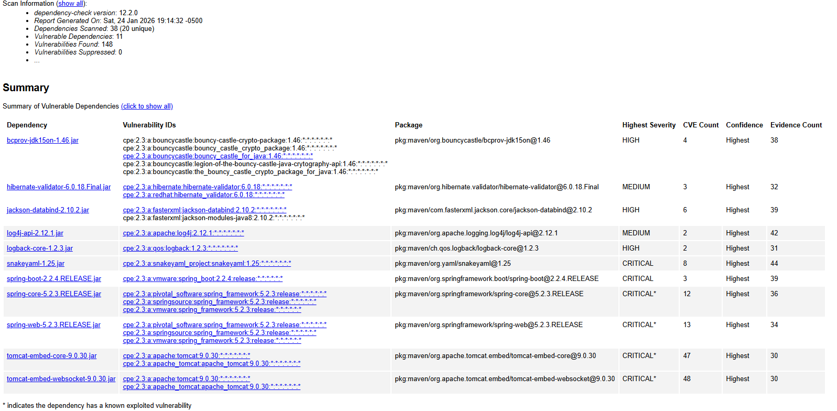
Dependency | Description | Solution
bcprov-jdk15on-1.46.jar | The Bouncy Castle Crypto package is a Java implementation of cryptographic algorithms. This jar contains JCE provider and lightweight API for the Bouncy Castle Cryptography APIs for JDK 1.5 to JDK 1.7. | The Bouncy Castle Crypto package is attached but never utilized within the code. There are many instances of injection into the structure therefore removing it and manually encrypting information or updating to a newer crypto package might be best.
hibernate-validator-6.0.18.Final.jar | Hibernate's Bean Validation (JSR-380) reference implementation. | Hibernate Validators before 6.2.0 and 7.0.0 had vulnerabilities that allowed attackers access to sensitive information, it would be best to update to a newer version as versions after 7.0.0 no longer had this issue.
jackson-databind-2.10.2.jar | General data-binding functionality for Jackson: works on core streaming API | This version of the jackson databind were found to not have entity expansion secured, allowing XML external entity attacks. As with the other items, an update would be beneficial for the application.
log4j-api-2.12.1.jar | The Apache Log4j API | This API has issues with not performing TLS hostname verifications which allows attackers to intercept or redirect traffic. Updating to Apache Log4j Core version 2.25.3 is the solution to this issue.
logback-core-1.2.3.jar | logback-core module | A serialization vulnerability allows attackers to utilize a Denial-of-Service attack by sending bad data. Updating to version 1.2.13 or higher would patch this issue for the application.
snakeyaml-1.25.jar | YAML 1.1 parser and emitter for Java | SnakeYaml’s constructor class does not restrict types that can be instantiated during deserialization which can lead to an attacker utilizing remote code execution. Upgrading to version 2.0 or higher closes this gap.
spring-boot-2.2.4.RELEASE.jar | Spring Boot | Versions older than 3.0.0 are susceptible to security bypasses due to an application deployed to Cloud Foundry. Users should utilize versions 3.0.6 and up or 2.7.11+.
spring-core-5.2.3.RELEASE.jar | Spring Core | Spring applications running on JDK 9+ may be vulnerable to remote code executions, updates must be applied per vendor instructions to mitigate this risk.
spring-web-5.2.3.RELEASE.jar | Spring Web | Versions through 5.3.16 have a potential remote code execution issue when used for Java deserialization of untrusted data, the vendor states that untrusted data is not intended use therefore no solutions were provided. Updates to newer versions should help this issue.
tomcat-embed-core-9.0.30.jar | Core Tomcat implementation | Apache Tomcat has improper privilege management and can give other connections aside from HTTP higher trust, which allows attackers to exploit these connections. Upgrading to versions 9.0.31, 8.5.51, or 7.0.100 or later fixes this issue.
tomcat-embed-websocket-9.0.30.jar | Core Tomcat implementation | As above, Tomcat has improper privilege management and should be updated to later versions to fix the issue.

5. Mitigation Plan

To mitigate any security vulnerabilities within Artemis Financials’ software the first step to take would be to update the input validation for the application. Any user input should be validated to make sure that they are inserting things properly and not trying to inject data or programs into these fields. The APIs should all be updated to the newest versions. As shown in the static testing review, many of the versions are outdated and are a threat in their own ways. Updates have been the most recommended solution to these issues. User data needs to be encrypted either manually or by utilizing an updated version of the Bouncy Castle Crypto package, especially due to the application dealing with client names, accounts, etcetera. The code should be completed, and the username and password for the database should not be hard coded into the application itself. Overall, there are plenty of things that need to be updated to modernize Artemis Financials’ software, but the biggest things needed are input validation, an update to all of the APIs used, and encryption of sensitive data.

